# Program-01

**Develop a program to illustrate the working of LED with push button**

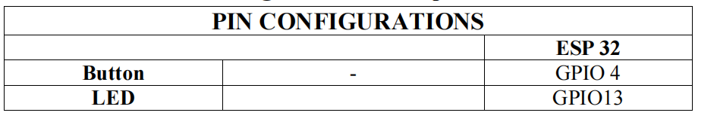#define buttonPin 4 // the number of the pushbutton pin

#define ledPin 13 // the number of the LED pin

int buttonState = 0; // variable for reading the pushbutton

void setup() {

// initialize the LED pin as an output:

pinMode(ledPin,OUTPUT);

// initialize the pushbutton pin as an input:

pinMode(buttonPin, INPUT);

}

void loop() {

buttonState = digitalRead(buttonPin);

// check if the pushbutton is pressed. If it is, the buttonState is HIGH:

if (buttonState == HIGH) {

// turn LED on:

digitalWrite(ledPin, LOW);

}

else {

// turn LED off:

digitalWrite(ledPin,HIGH);

}

}

OUTPUT

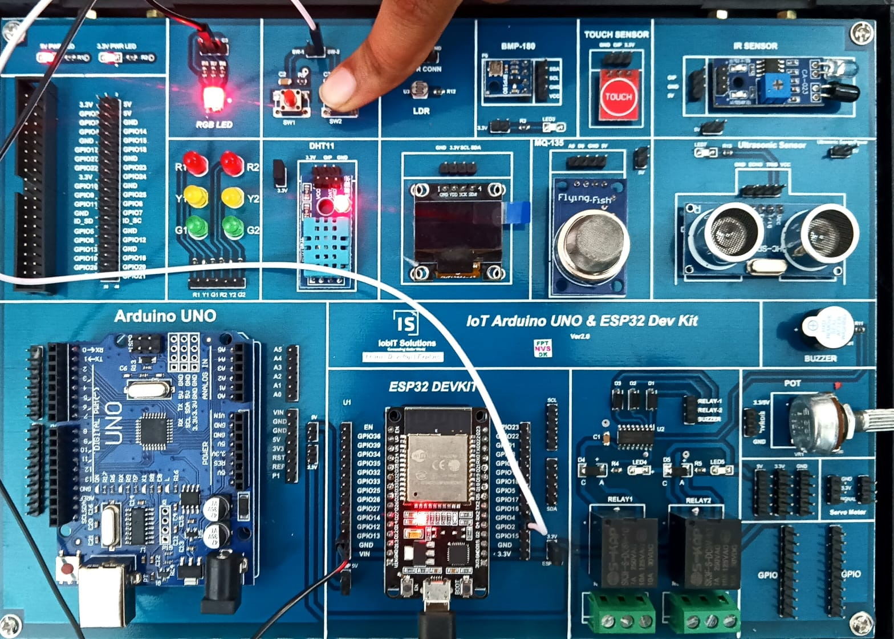

**Program –02**

**Develop a program to illustrate the working of traffic lights for pedstrians.**

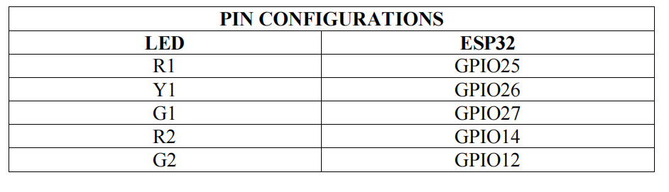// Pin definitions

const int carRed = 25;

const int carYellow = 26;

const int carGreen = 27;

const int pedRed = 14;

const int pedGreen = 12;

void setup() {

// Set LED pins as output

pinMode(carRed, OUTPUT);

pinMode(carYellow, OUTPUT);

pinMode(carGreen, OUTPUT);

pinMode(pedRed, OUTPUT);

pinMode(pedGreen, OUTPUT);

// Initialize traffic light (green for cars, red for pedestrians)

digitalWrite(carGreen, HIGH);

digitalWrite(pedRed, HIGH);

}

void loop() {

// Step 1: Green light for cars, red for pedestrians

digitalWrite(carGreen, HIGH);

digitalWrite(carYellow, LOW);

digitalWrite(carRed, LOW);

digitalWrite(pedGreen, LOW);

digitalWrite(pedRed, HIGH);

delay(5000); // Cars move for 5 seconds

// Step 2: Yellow light for cars, red for pedestrians

digitalWrite(carGreen, LOW);

digitalWrite(carYellow, HIGH);

delay(2000); // Yellow light for 2 seconds

// Step 3: Red light for cars, green for pedestrians

digitalWrite(carYellow, LOW);

digitalWrite(carRed, HIGH);

digitalWrite(pedRed, LOW);

digitalWrite(pedGreen, HIGH);

delay(5000); // Pedestrians cross for 5 seconds

// Step 4: Flash yellow light for cars before green light

digitalWrite(pedGreen, LOW);

digitalWrite(pedRed, HIGH);

for (int i = 0; i < 3; i++) {

digitalWrite(carYellow, HIGH);

delay(500);

digitalWrite(carYellow, LOW);

delay(500);

}

}

OUTPUT

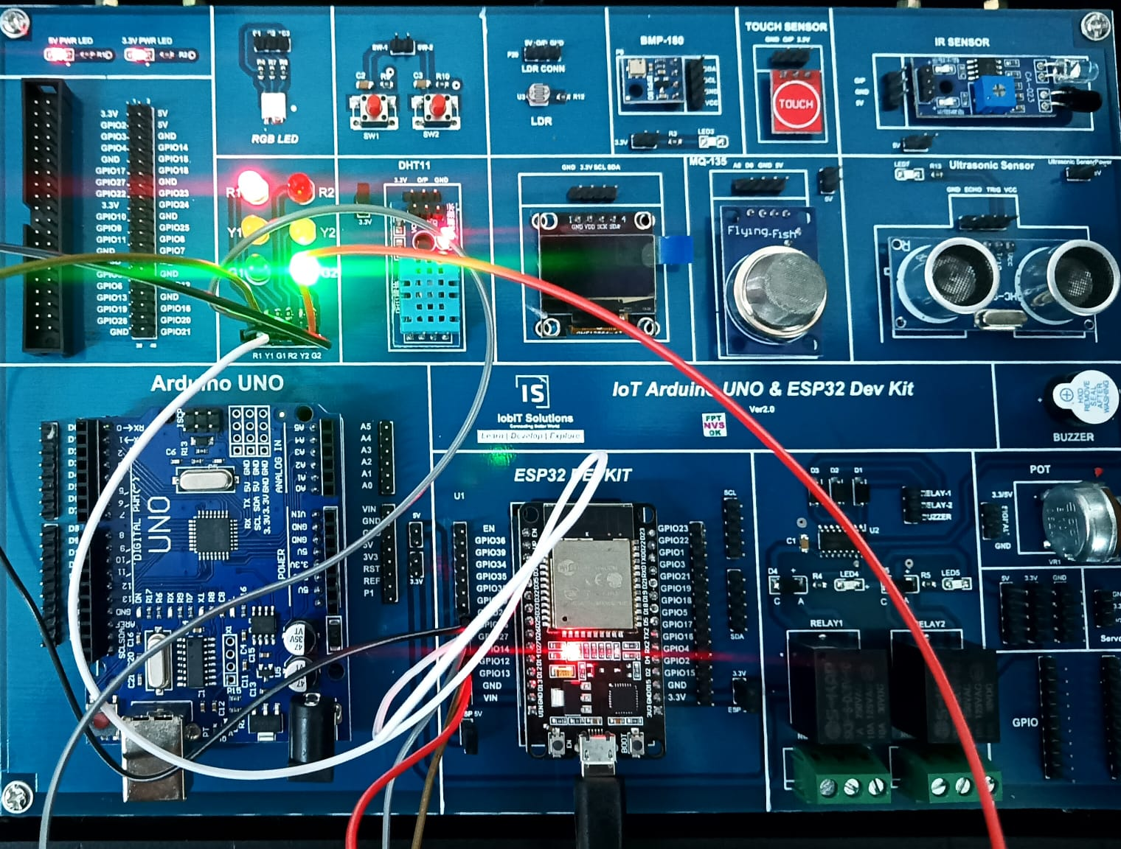

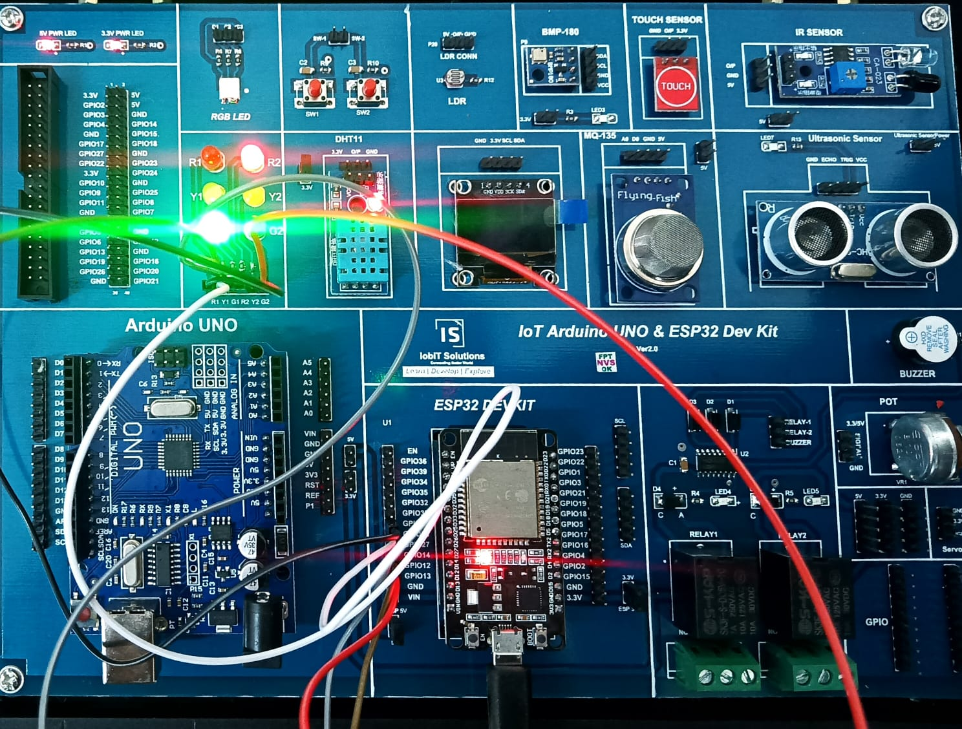

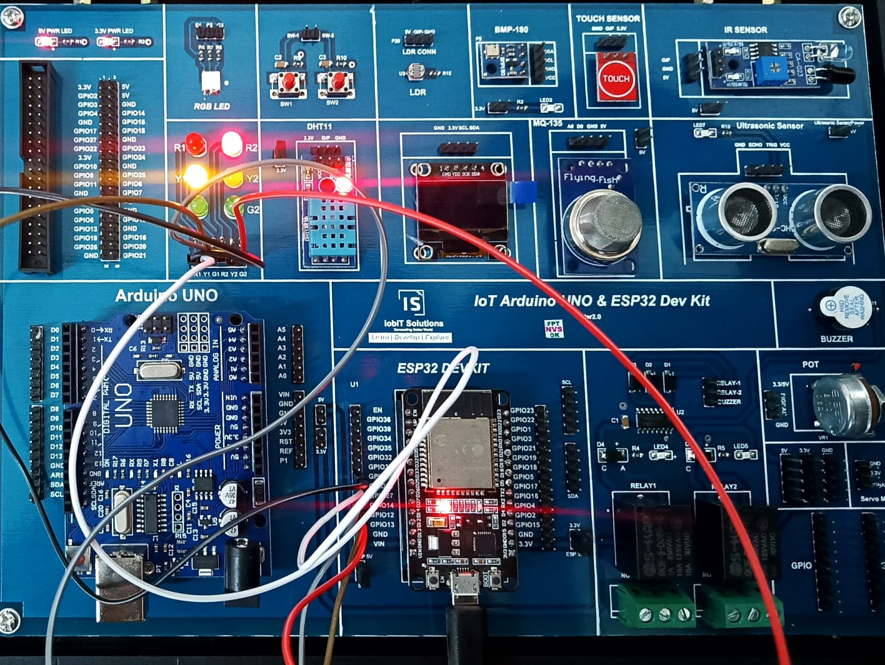

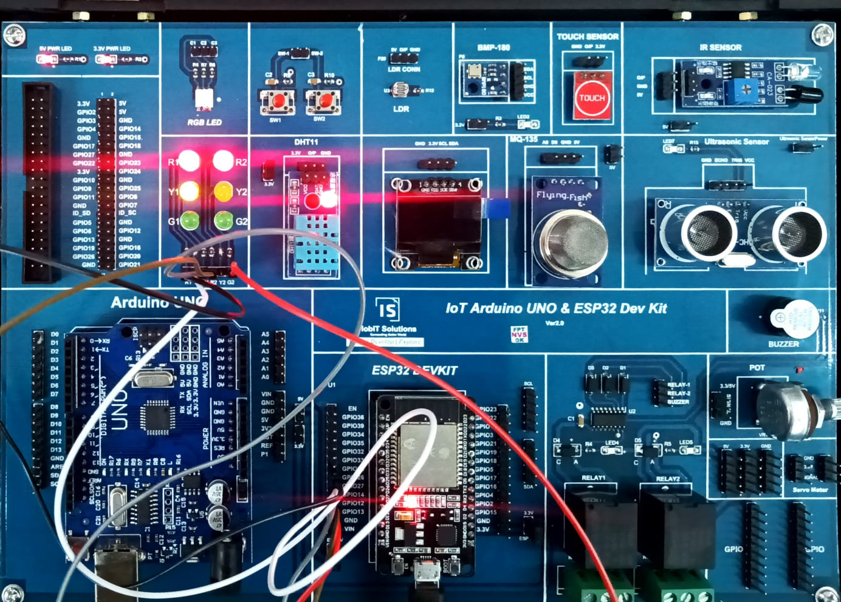

**PROGRAM—03**

**Develop a program for fading the LED**

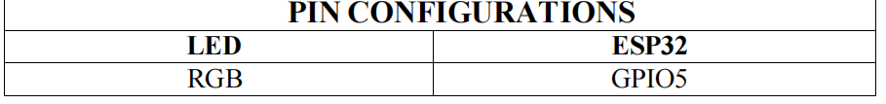#define ledPin 5 // Pin for the LED (can be changed based on yourboard)

int brightness = 0; // Initial brightness level

int fadeAmount = 5; // Amount by which the brightness will increase/decrease

void setup() {

// Set the LED pin as an output

pinMode(ledPin, OUTPUT);

}

void loop() {

// Set the brightness of the LED using PWM

analogWrite(ledPin, brightness);

// Change the brightness for the next loop

brightness = brightness + fadeAmount;

// Reverse the direction of the fading if brightness reaches max or min

if (brightness <= 0 || brightness >= 255) {

fadeAmount = -fadeAmount;

}

// Delay for a smoother fading effect

delay(30); // Adjust this for faster/slower fading

}

**OUTPUT:**

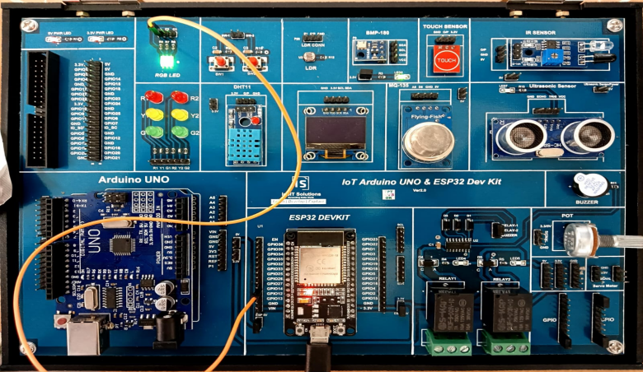

**Program 4.**

**Program to blink 6 LEDs in ODD and Even Fashion.**

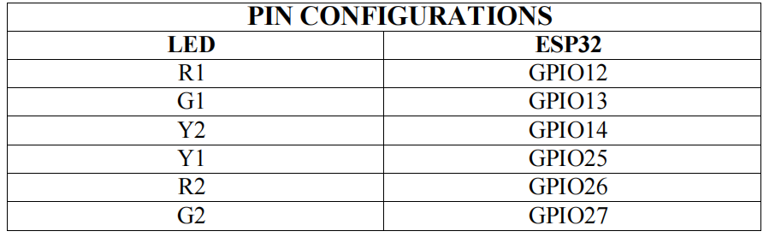// Pin definitions for the odd and even LEDs

#define led1 12 // Odd

#define led3 13 // Odd

#define led5 14 // Odd

#define led2 25 // Even

#define led4 26 // Even

#define led6 27 // Even

void setup() {

// Set all the LED pins as outputs

pinMode(led1, OUTPUT);

pinMode(led2, OUTPUT);

pinMode(led3, OUTPUT);

pinMode(led4, OUTPUT);

pinMode(led5, OUTPUT);

pinMode(led6, OUTPUT);

}

void loop() {

// Turn on all odd-numbered LEDs (1, 3, 5)

digitalWrite(led1, HIGH);

digitalWrite(led3, HIGH);

digitalWrite(led5, HIGH);

// Turn off all even-numbered LEDs (2, 4, 6)

digitalWrite(led2, LOW);

digitalWrite(led4, LOW);

digitalWrite(led6, LOW);

delay(1000); // Wait for 1 second

// Turn off all odd-numbered LEDs (1, 3, 5)

digitalWrite(led1, LOW);

digitalWrite(led3, LOW);

digitalWrite(led5, LOW);

// Turn on all even-numbered LEDs (2, 4, 6)

digitalWrite(led2, HIGH);

digitalWrite(led4, HIGH);

digitalWrite(led6, HIGH);

delay(1000); // Wait for 1 second

}

OUTPUT:

EVEN FASHION

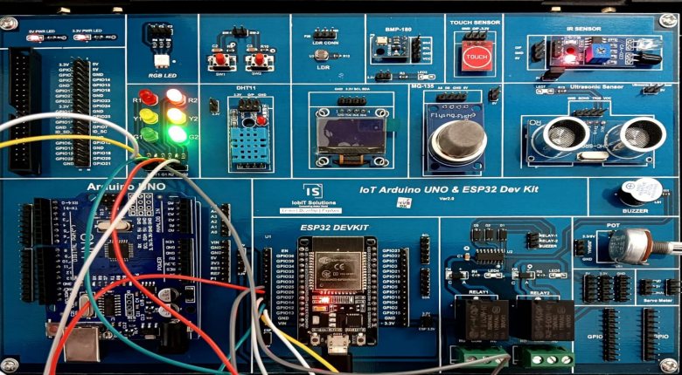

ODD FASHION

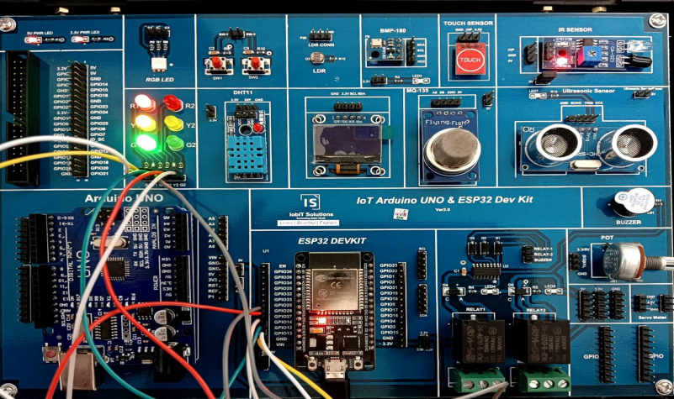

**5. Program to rotate servo motor both in clockwise and**

**anticlockwise direction.**

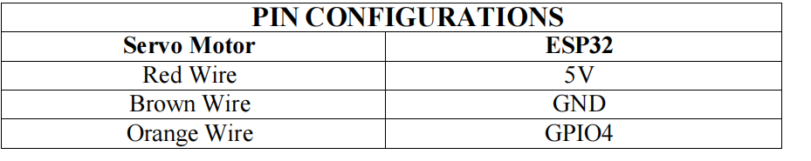

#include <ESP32Servo.h> // Include the ESP32 Servo library

Servo myServo; // Create a Servo object

int pos = 0; / / Variable to store the servo position

void setup() {

myServo.attach(4); // Attach the servo to pin 4

}

void loop() {

// Rotate the servo clockwise (from 0 to 180 degrees)

for (pos = 0; pos <= 180; pos += 1) {

myServo.write(pos); // Set the servo to the current position

delay(15); // Wait for 15ms for the servo to reach the position

}

// Rotate the servo anticlockwise (from 180 back to 0 degrees)

for (pos = 180; pos >= 0; pos -= 1) {

myServo.write(pos); // Set the servo to the current position

delay(15); // Wait for 15ms for the servo to reach the position

}

}

OUTPUT:

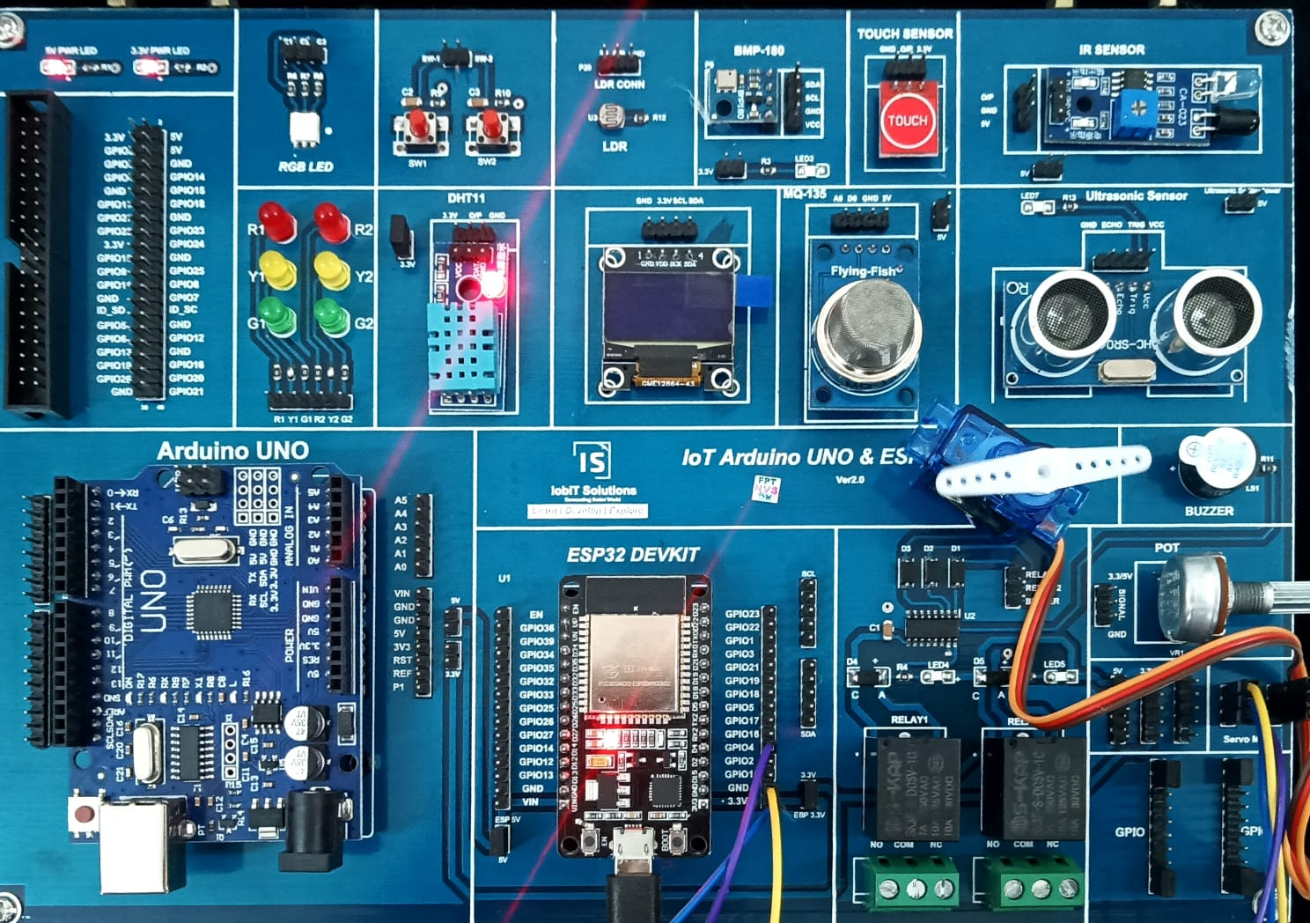

**PROGRAM-06**

**Develop a program to simulate the interfacing of LDR with Arduino and control the intensity of LED using LDR**

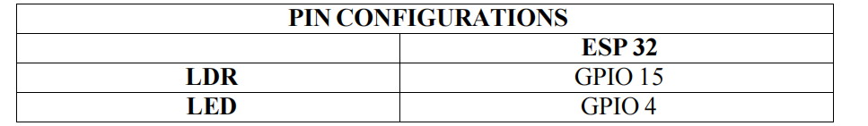#define ldrPin 15 // Pin connected to the LDR

#define ledPin 4 // Pin connected to the LED

int ldrValue = 0; // Variable to store LDR reading

int ledBrightness = 0; // Variable to store LED brightness

void setup() {

pinMode(ledPin, OUTPUT); // Set the LED pin as output

Serial.begin(9600); // Start serial communication for debugging

}

void loop() {

// Read the value from the LDR (0 to 1023)

ldrValue = analogRead(ldrPin);

// Map the LDR value to a range of 0 to 255 for PWM (LED brightness)

ledBrightness = map(ldrValue, 0, 1023, 0, 255);

// Set the brightness of the LED using PWM

analogWrite(ledPin, ledBrightness);

// Debugging information

Serial.print("LDR Value: ");

Serial.print(ldrValue);

Serial.print(" LED Brightness: ");

Serial.println(ledBrightness);

delay(100); // Short delay for stability

}

OUTPUT:

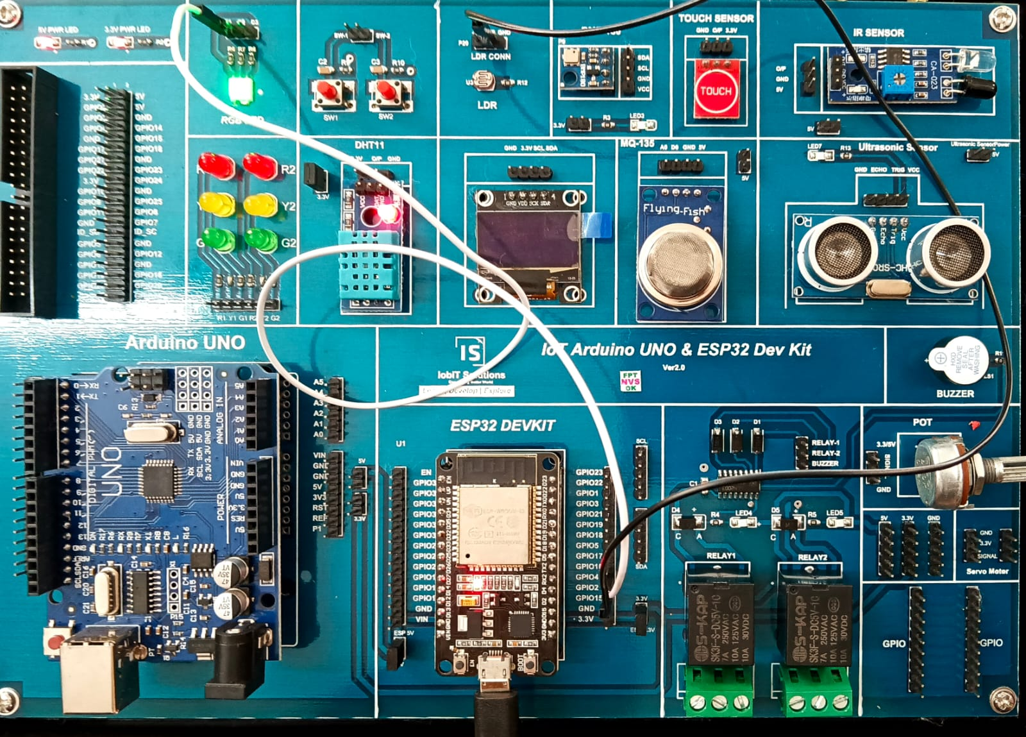

**PROGRAM-07**

**Develop program to simulate the working of potentiometer and LED by varying the intensity of LED using potentiometer.**

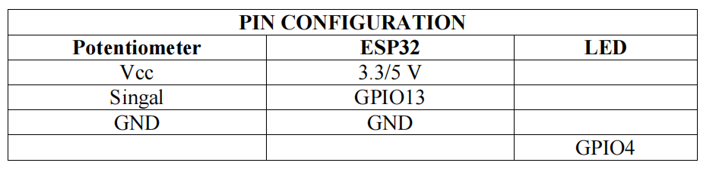#define potPin 15 // Pin connected to the PoT

#define ledPin 4 // Pin connected to the LED

int potValue = 0; // Variable to store PoT reading

int ledBrightness = 0; // Variable to store LED brightness

void setup() {

pinMode(ledPin, OUTPUT); // Set the LED pin as output

Serial.begin(9600); // Start serial communication for debugging

}

void loop() {

// Read the value from the PoT (0 to 1023)

potValue = analogRead(potPin);

// Map the PoT value to a range of 0 to 255 for PWM (LED brightness)

ledBrightness = map(potValue, 0, 1023, 0, 255);

// Set the brightness of the LED using PWM

analogWrite(ledPin, ledBrightness);

// Debugging information

Serial.print("Pot Value: ");

Serial.print(potValue);

Serial.print(" LED Brightness: ");

Serial.println(ledBrightness);

delay(100); // Short delay for stability

}

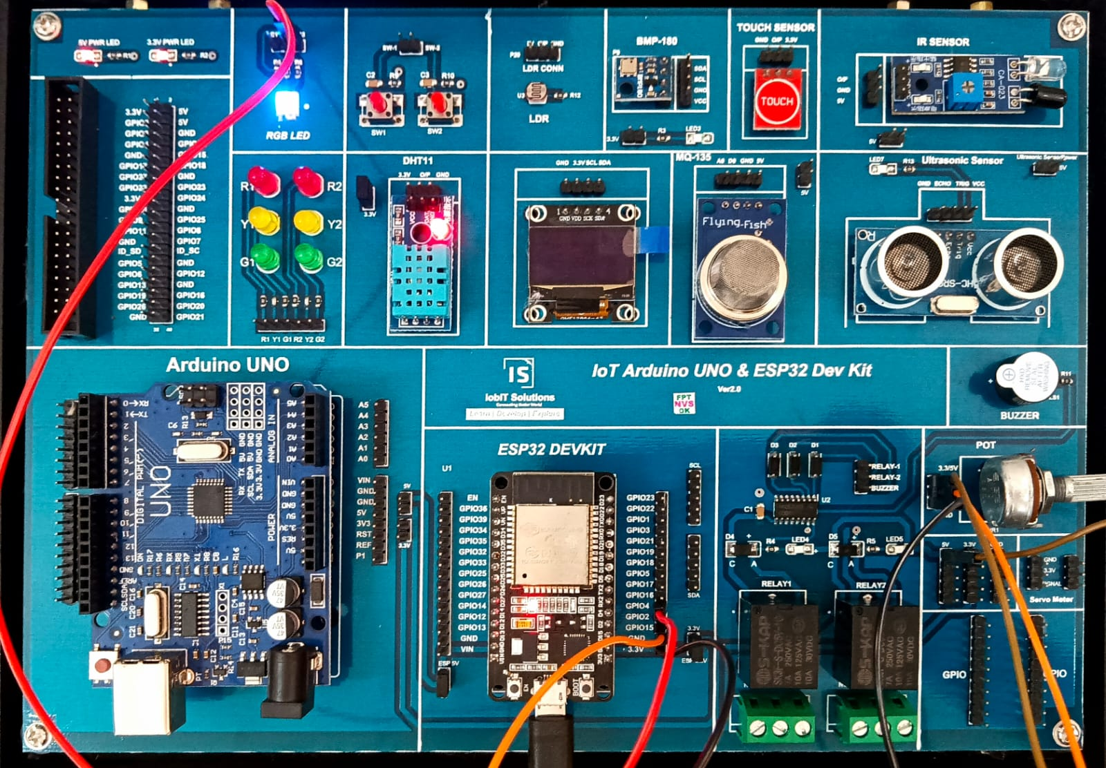

**8. Program to simulate the working of OLED and print the room**

**temperature value on OLED.**

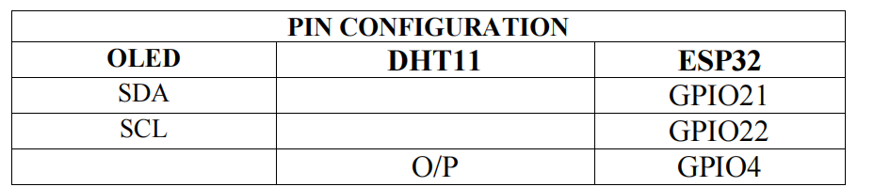#include <Wire.h>//

#include <Adafruit_GFX.h>

#include <Adafruit_SSD1306.h>

#include "DHT.h"

#define DHTPIN 4 // Pin connected to the DHT11 sensor

#define DHTTYPE DHT11 // Type of DHT sensor

#define SCREEN_WIDTH 128 // OLED display width, in pixels

#define SCREEN_HEIGHT 64 // OLED display height, in pixels

// Declaration for an SSD1306 display connected to I2C (SDA, SCL pins)

Adafruit_SSD1306 display(SCREEN_WIDTH, SCREEN_HEIGHT, &Wire,

-1);

DHT dht(DHTPIN, DHTTYPE);

float t = 0,h = 0;

void setup() {

Serial.begin(9600);

// Initialize the OLED display

if(!display.begin(SSD1306_SWITCHCAPVCC, 0x3C)) {

Serial.println(F("SSD1306 allocation failed"));

}

dht.begin();

}

void loop() {

t = dht.readTemperature();

h = dht.readHumidity();

display.clearDisplay();

display.setTextSize(1);

display.setTextColor(SSD1306_WHITE);

display.setCursor(0,0);

display.print("Temperature = ");

display.println(t);

display.print("Humidity = ");

display.println(h);

display.display();

delay(3000);

}

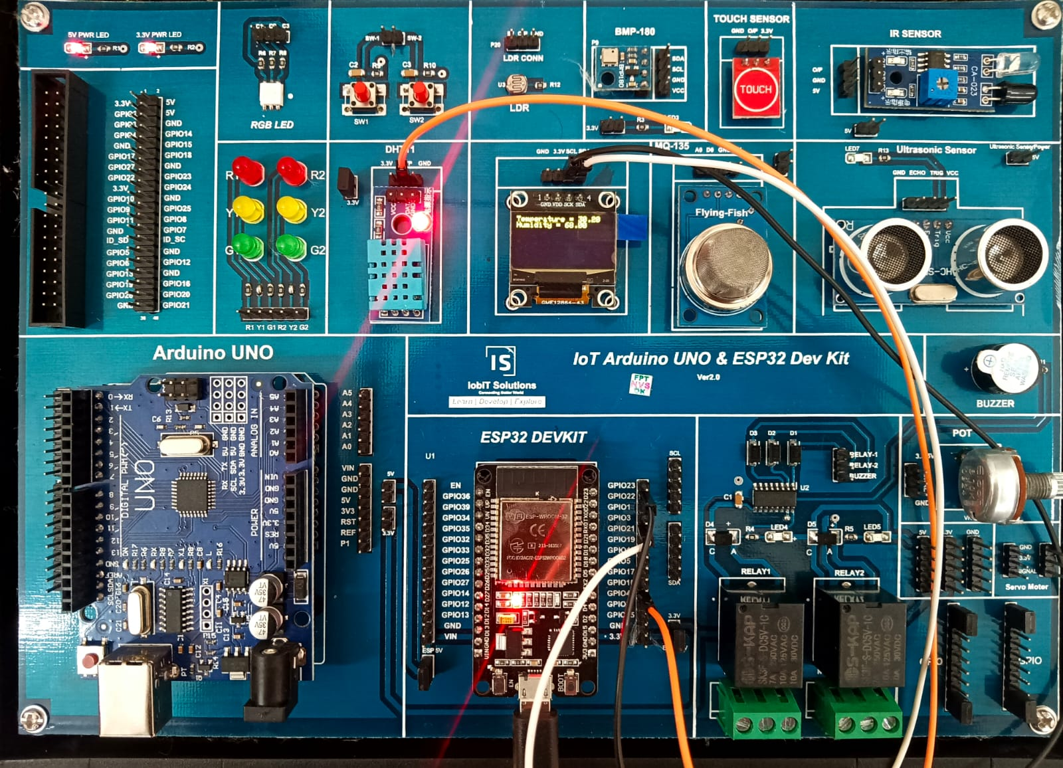

**9. Program for scrolling 5 LEDs back and forth.**

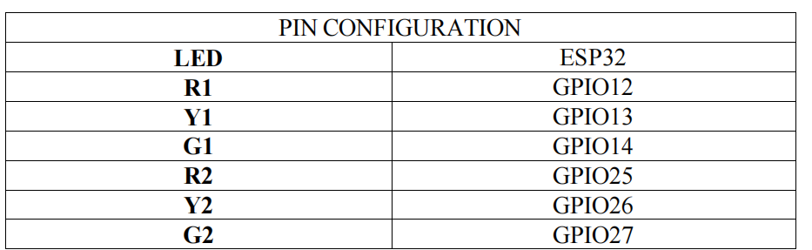// Pin definitions for the 5 LEDs

const int ledPins[] = {12, 13, 14, 25, 26, 27}; // Define LED pins

const int numLeds = 6; // Total number of LEDs

void setup() {

// Set all the LED pins as outputs

for (int i = 0; i < numLeds; i++) {

pinMode(ledPins[i], OUTPUT);

}

}

void loop() {

// Scroll LEDs from left to right (forward)

for (int i = 0; i < numLeds; i++) {

digitalWrite(ledPins[i], HIGH); // Turn on the current LED

delay(200); // Wait for 200ms

digitalWrite(ledPins[i], LOW); // Turn off the current LED

}

// Scroll LEDs from right to left (backward)

for (int i = numLeds - 1; i >= 0; i--) {

digitalWrite(ledPins[i], HIGH); // Turn on the current LED

delay(200); // Wait for 200ms

digitalWrite(ledPins[i], LOW); // Turn off the current LED

}

}

OUTPUT:

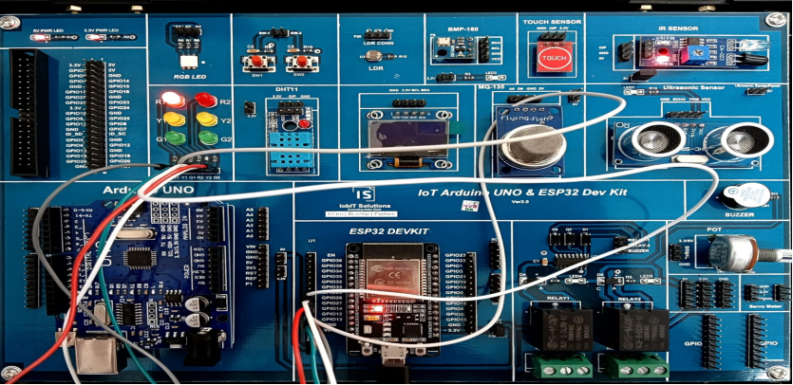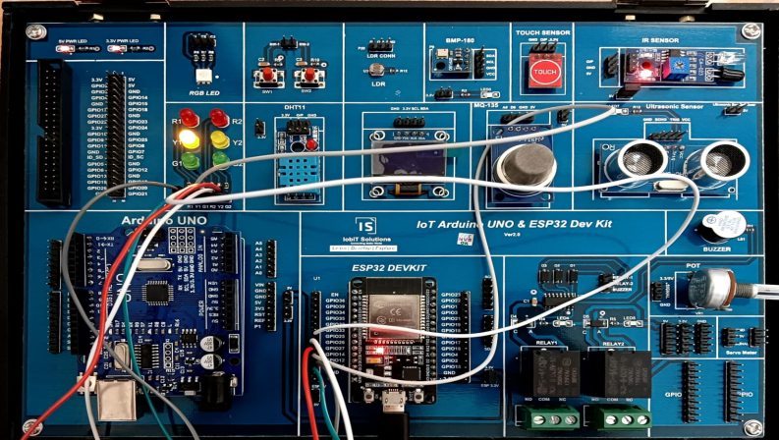

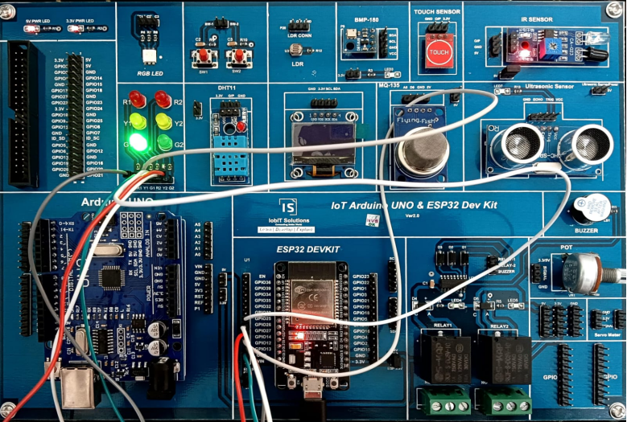

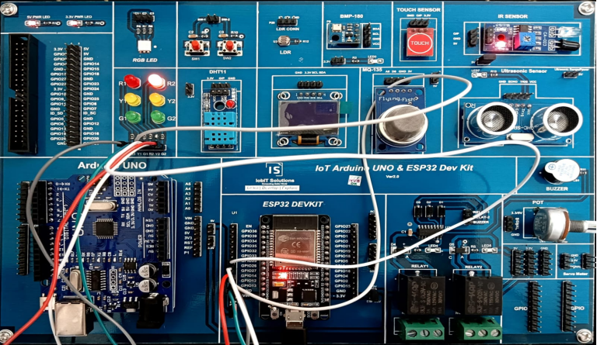

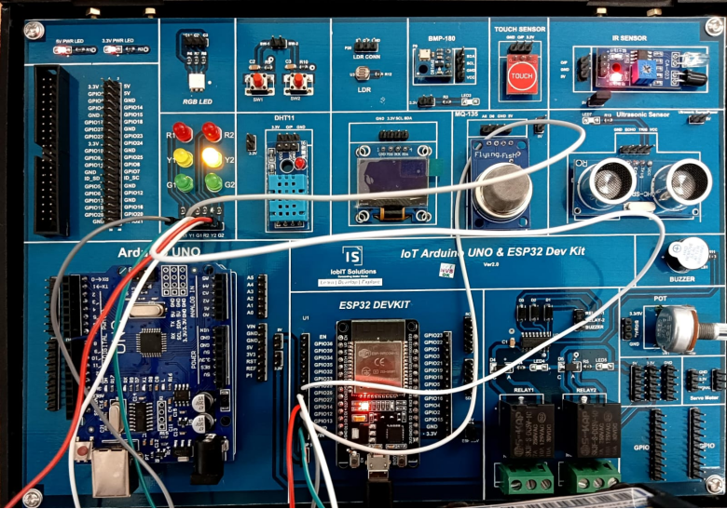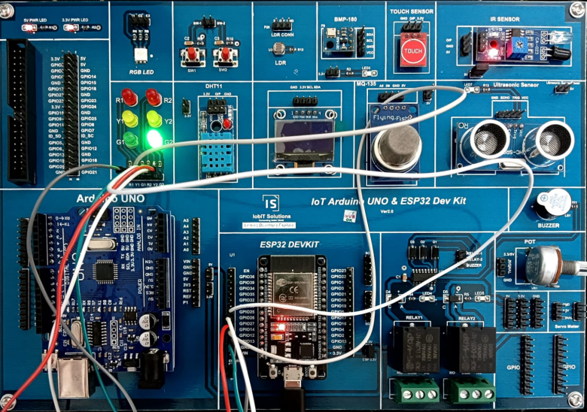

**10. Program to calculate the distance of an object using ultrasonic sensor.**

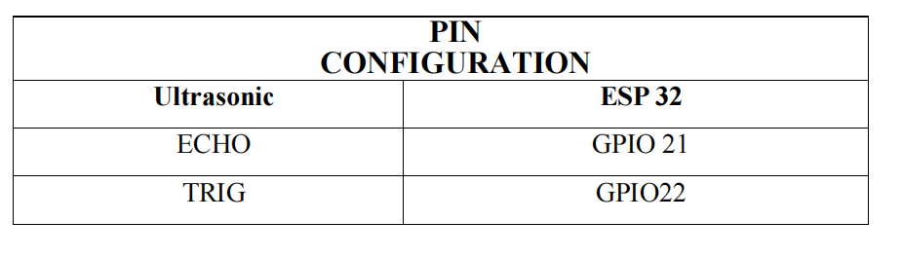#include <Ultrasonic.h>

#define TRIG 5

#define ECHO 4

Ultrasonic US(TRIG, ECHO);

int distance ;

void setup() {

Serial.begin(9600);

}

void loop() {

// Pass INC as a parameter to get the distance in inches

distance = US.read();

Serial.print("Distance in CM: ");

Serial.println(distance);

delay(1000);

}

OUTPUT:

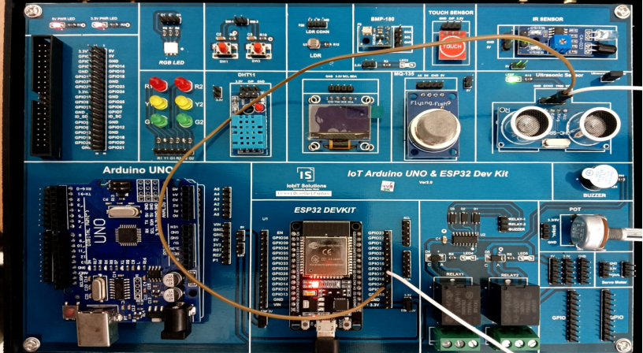

**11. Program to detect the collision using infrared sensor.**

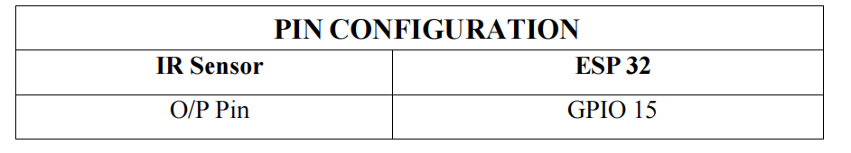#define IR 15

void setup() {

// put your setup code here, to run once:

pinMode(IR,INPUT);

Serial.begin(9600);

}

void loop() {

// put your main code here, to run repeatedly:

int ir = digitalRead(IR);

// Serial.print(ir);

// delay(500);

if(ir == 1)

Serial.println("Object Not Detected");

else

Serial.println("Object Detected");

delay(1000);

}

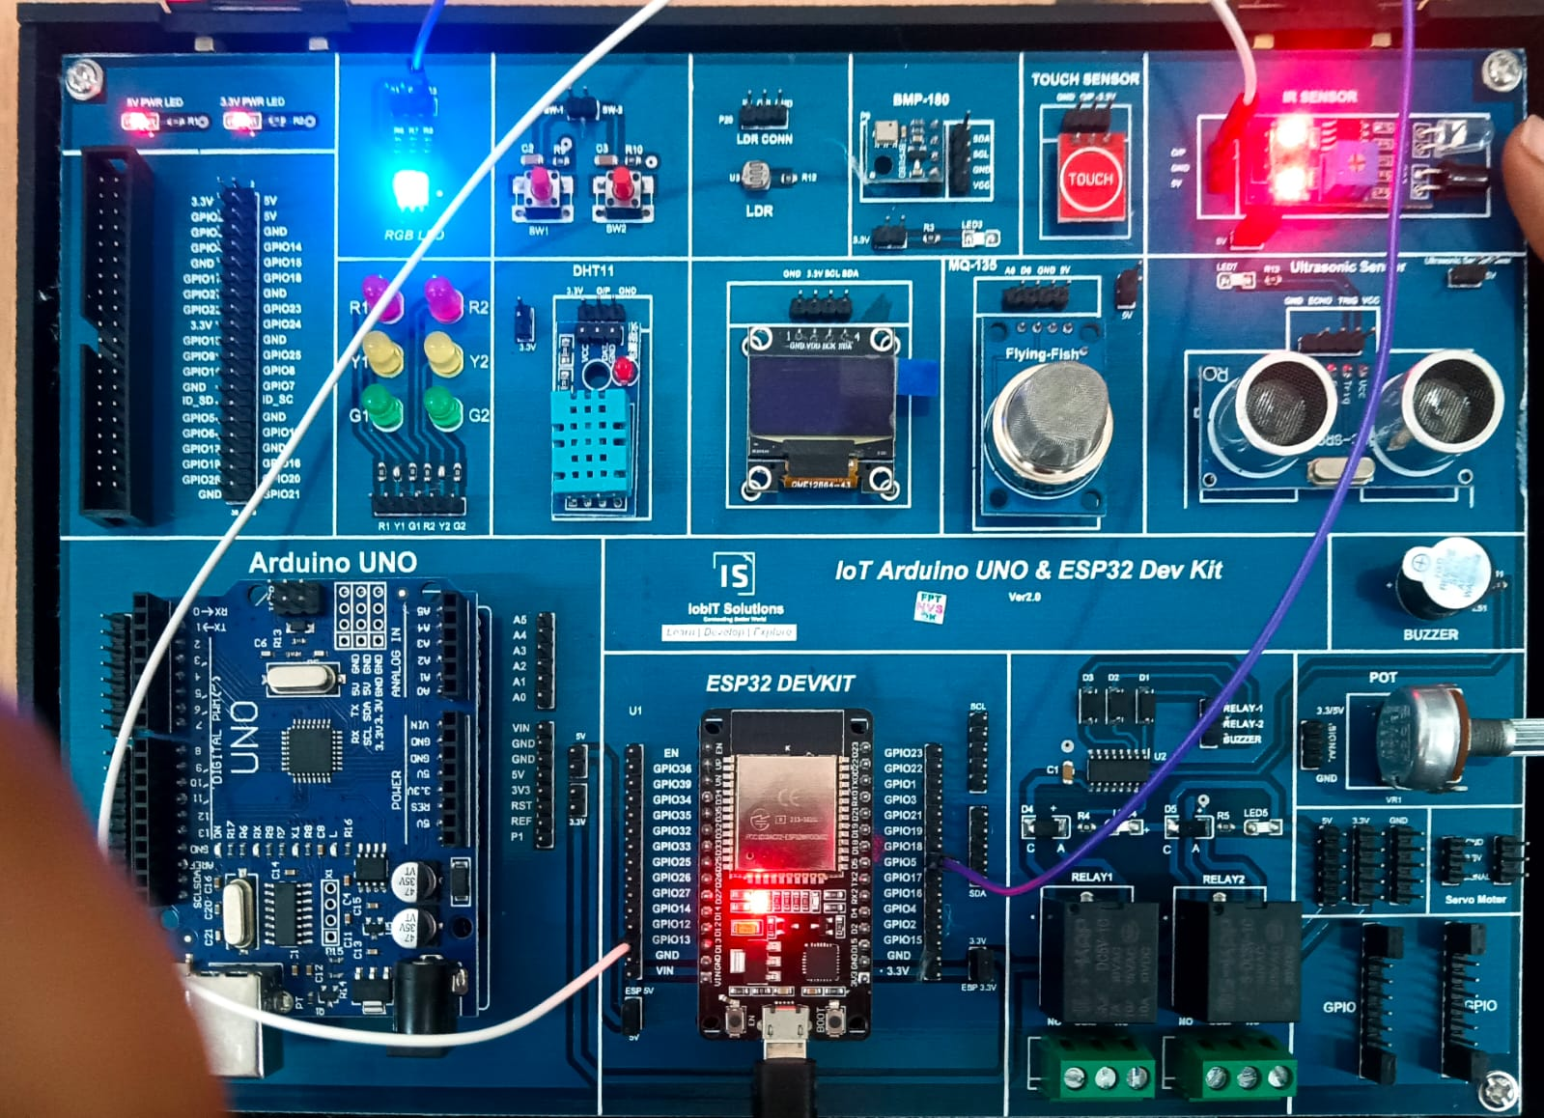

**12. Program to interface temperature sensor to read the room temperature, humidity and heat index and print the readings on the serial monitor.**

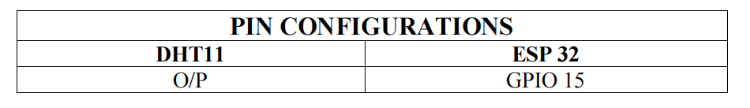#include "DHT.h"

#define DHT11PIN 4

DHT dht(DHT11PIN, DHT11);

void setup() {

Serial.begin(9600); // Start the DHT11 Sensor

dht.begin();

}

void loop() {

float humi = dht.readHumidity();

float temp = dht.readTemperature();

// Using String() to concatenate

Serial.print("Temperature");

Serial.println(temp);

Serial.print("Humidity");

Serial.println(humi);

delay(1000); // 1-second delay between readings

}

OUTPUT:

